# Lab: Ownership Chain

|  |
| --- |
| * This is an in-class lab and due tonight. * Use the following naming convention: homework, underscore, last name, first initial, and extension (e.g., Lab_Ownchain_ImG.docx). |

Provide the answers in light of ownership chains.

* (**Task 1**) Show the outcome of this task in a screenshot. Also, explain briefly why you have received the result.

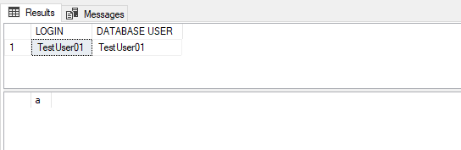

I think it came with no error because, we are logged into the TestUser01 which already has been granted permissions to execute on sp1 and tb11, “a” is showing because sp1 is a procedure and it selected it from tb11

* (**Task 2**) Show the outcome of this task in a screenshot. Also, explain briefly why you have received the result.

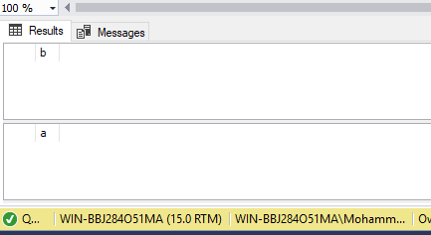

Again the result had no errors as we are still logged into TestUser01, which has permission to execute on sp1 and tbl2, this time we have “a” and “b” showing because sp2 was a procedure that selected “b” from tbl2. Sp2 also executes sp2inner which was procedure that selected “a” from tbl1 even when we did not have permission.

* (**Task 3**) Show the outcome of this task in a screenshot. Also, explain briefly why you have received the result.
* 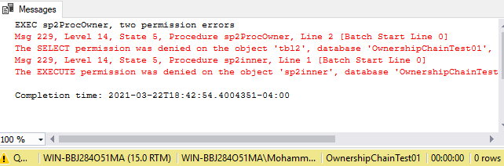

The query did not work since sp2ProcOwner authorization was transition to ProcOwner01. TestUser01 cant execute sp2ProcOwner procedure. The reason for that is the statement execute inside of of sp2inner procedure which we don’t have access to, and since we don’t have a privilege to access it we can no longer have access to sp2inner.

* (**Task 4**) Show the outcome of this task in a screenshot. Also, explain briefly why you have received the result.

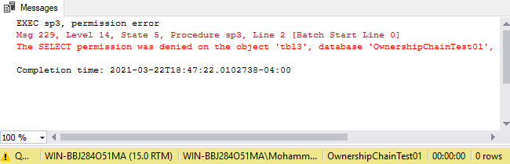

This did not work either because sp3 was moved to TableOwner01, so TestUser01 does not have permission for that.

* (**Task 5**) Show the outcome of this task in a screenshot. Also, explain briefly why the result is different from the one from Task #4?

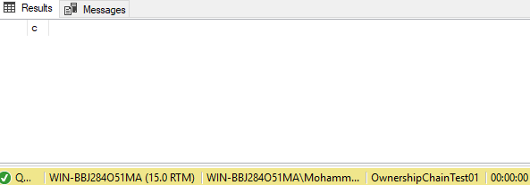

This query worked because Admin has all the permission and privileges, admin can execute/read/write anything, sp3 is also seen as “c”